Distributed Order Management

September 2022

Business Problem: Client was facing low fulfilment rates, high penalties, and stock-outs due to the static allocation rules to fulfil the orders. It was tedious task to manually divert orders to the alternate DC by high-level checks on inventory and labor availability. There have been frequent stock-outs owing to high demand variability, inaccurate forecasts, stock-outs at the plant, inventory unavailability at default DC, delayed stock transfers etc resulting in significant lost sales and penalties from customers.

Expected Solution: We have developed an optimization model to minimize the lost sales and penalties by identifying the optimal DC while factoring in inventory, transportation costs, labor, and dock availability to provide divert recommendations. The solution also provides trade-off options for planners to approve/reject recommendations.

Solution Components: The optimization model minimizes penalty and maximizes fill rate (COF)....
- Considering all open orders except credit block orders for which the delivery note is not dropped from 3 days after current date to 10 working days.
- Checking for inventory availability for these open orders at default DC and considering orders with insufficient inventory for all customers.
- Check for full truckloads (FTLs) and less than truckloads (LTLs).
- Orders with insufficient inventory and meeting the FTL criteria will be considered as focus orders. While classifying the focus orders, fines/penalty information is not considered.
- These focus orders will go as an input to the model run.
- In-transit and incoming load plans will be considered in inventory from the next day. Incoming dispatch plan will not be considered.

Criteria to suggest diverts:
- Key criteria for the optimization model are checking for higher fulfilment rates and minimizing penalty/shipping cost while considering case pick, pallet pick constraints and dock availability constraints at the DC level.
- Model gives priority to soft allocation orders i.e., it tries to fulfil them from default DC. If the inventory available at default DC cannot fulfil the priority 8 orders, then they will be considered in the focus order list.
- It considers available inventory at the alternate DC after allocating inventory for default orders. It checks for:
1. Inventory available on PGI date and
2. Sufficient inventory available for all default orders for next 5 days.
- While suggesting a divert, model will also consider the revised lead times and suggests new PGI dates to meet the RDD.
- The Model aims to provide divert recommendations based on combination of maximizing fulfilment rate, minimizing penalty and shipping cost.
- An order can only be diverted if it results in at least 5% fill rate increase at alternative DC compared to the default DC.
- Model doesn’t recommend a divert if any SKU is not part of the forecast at the alternative DC.
- While diverting the orders, expected PGI (Planned goods issue) will not fall on holiday days because we have incorporated the holiday calendar into the model. This holiday calendar includes weekends (Saturdays and Sundays) and other holidays where the DCs are not operational.
- If there is a throughput constraint at a DC, then the model checks for the available capacity for consecutive 3 days at a DC, it will then add the inventory available orders to the focus orders
Below waterfall explains the order flow
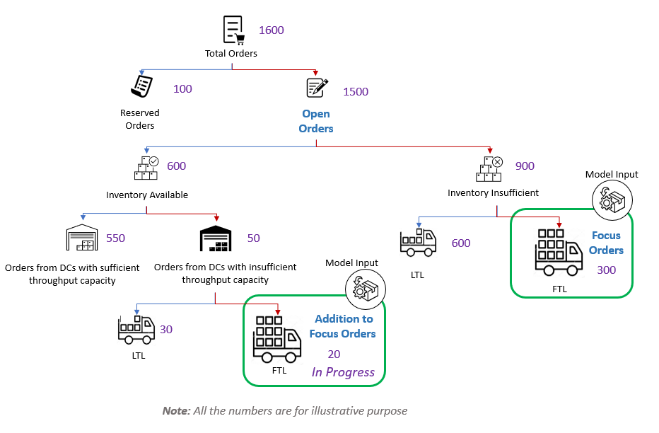

Input Data – We have details of all skus, default distribution center (dc), planned goods issue date(pgidate) etc. for focus orders.

- Combination of orders and DC
Orders/DCs | DC1 | DC2 | DC3 | Note
Order1 | 0 | 0 | 1 | Order1 will be fulfilled from DC3
Order2 | 1 | 0 | 0 | Order2 will be fulfilled from DC1
Order3 | 0 | 1 | 0 | Order3 will be fulfilled from DC2

$$Decision Variable:$$
$$A_{od}→Binary variable, value 1 denotes that order o will be fullfilled from dc d$$
$${Cases}_{osdp}→Continuous variable, it denotes cases filled for order o and sku a at plant or dc d and pgidate p$$
$${Casepick}_{osdp}→Continuous variable, it denotes Casepicks required for order o, sku s, if fullfilled from dc d at pgi p.$$
$${Palletpick}_{osdp}→Continuous variable, it denotes Palletpicks required for order o, sku s, if fullfilled from dc d at pgi p.$$
$${Penalty_Activation1}_{o}→Binary variable, value 1 indicates penalty for order o$$
$${Penalty_Activation2}_{o}→Binary variable, value 1 indicates no penalty for order o$$
$${Penalty_Cases1}_{os}→Integer variable, it denotes cases filled for order o and sku s when there is penalty for order o, otherwise zero$$
$${Penalty_{Cases2}}_{os}→Integer variable, it denotes cases filled for order o and sku s when there is no penalty for order o,otherwise zero$$
$${Default_case_act1}_{os}→binary variable,value 1 denotes, complete ordered cases for order o and sku s is available at default dc.$$
${Default_case_act2}_{os}→binary variable,value 1 denotes,complete ordered cases for order o and sku s are not available at default dc$ ${Default_case1}_{os}→Integer variable$
${Default_case2}_{os}→Integer variable,denotes cases filled at default dc and default pgi of order o for sku s.$

$$Model parameters:$$
$${Default_Inv}_{dsp}→Cases available for default orders of sku s, at dc d,and date p.$$
$${NonDefault_Inv}_{dsp}→ Cases available for Diverted orders of sku s, at dc d,and date p.$$
$${Dock_Capacity}_{dp}→Dock available at dc d,and date p.$$
$${Casepick_Capacity}_{dp}→CasePick available at dc d,and date p.$$
$${PalletPick_Capacity}_{dp}→PalletPick available at dc d,and date p.$$
$${Order_skuprice}_{os}→price of sku s for order o.$$
$${Order_sku_demand}_{os}→orderedqty of sku s for order o.$$
$${Ordered_Qty}_{o}→total orderedqty for order o.$$
$${Order_perc_penalty}_{o}→percentage penalty for order o on potential cuts.$$
$${Order_level_threshold}_{o}→threshold value of cases to decide there will be penalty or not for order o.$$
$${ShippingCost}_{od}→Shipping cost for order o from dc d.$$
$${Casesperpallet}_{s}→number of cases in one pallet of sku s$$

$$Objective Function:Max (Revenue-Penalty-Shipping Cost)$$

$Revenue=\sum{{Cases}_{osdp}*}{Order_skuprice}_{os} for osdp in order sku dc pgidate combination$

Penalty = $\sum{({Order_sku_demand}_{os}*}{Penalty_Activation1}_{o}-{Penalty_{Cases1}}_{os})* {Order_{skuprice}}_{os}*{Order_perc_penalty}_{o }for os in order sku combination$ $Shipping Cost=\sum{{ShippingCost}_{od}*}A_{od} for od in order dc combination$
$$Constraints:$$
$$constraint 1:one order can not be fullfilled from multiple dcs$$
$$for order o1,\sum{A_{od}}≤1 for od in order dc combination and o==o1$$
$$constraint 2:for an order cases filled should be less than the ordered qty$$
${Cases}_{osdp}≤A_{od}*{Order_sku_demand}_{os} for osdp in order sku dc pgidate combination$
$$constraint 3:Inventory Constraint$$
${DefaultCasesfilled}_{dsp}= \sum{{Cases}_{osdp}}for osdp in order sku dc pgidate combination if d is the default dc of o$
$${NonDefaultCasesfilled}_{dsp}= \sum{{Cases}_{osdp}}for osdp in order sku dc pgidate combination if d is not the default dc of o$$
$${DefaultCasesfilled}_{dsp}+{NonDefaultCasesfilled}_{dsp} ≤{Default_Inv}_{dsp}$$
$${NonDefaultCasesfilled}_{dsp} ≤{min⁡(NonDefault_{Inv}}_{dsq}for q in range(p,p+5))$$
$constraint 4:For a Diverted order there should be atleast$5 % increase in the fill rate compared to default dc and increase of 100 cases
${Casesfillableatdefaultdc}_{o}$ = Cases fillable for order o at its default dc
$${Casesfilled}_{o1d1}= \sum{{Cases}_{osdp}}for osdp in order sku dc pgidate combination if o==o1 and d==d1$$
$${Casesfilled}_{od}-{Casesfillableatdefaultdc}_{o}≥1.05*A_{od}*{OrderedQty}_{o} for od in order dc combination$$
$$constraint 5:Constraint for casepick and pallet picks$$
$${Casespick}_{osdp}≤{Casesperpallet}_{s}-1 for osdp in order sku dc pgidate combination$$
$${Casespick}_{osdp}+ {Palletpick}_{osdp}* {Casesperpallet}_{s}=={Cases}_{osdp}$$
$${Casespickreq}_{d1p1}= \sum{{Casespick}_{osdp}}for osdp in order sku dc pgidate combination if d==d1 and p==p1$$
$${Palletpickreq}_{d1p1}= \sum{{Palletpick}_{osdp}}for osdp in order sku dc pgidate combination if d==d1 and p==p1$$

$constraint 6:Constraint for dock$appointment
- Assumption: one dock is required for one order
$${dockreq}_{d1p1}= \sum{A_{od}}for od in order dc combination if d==d1 and pgi date for order o at dc d is p1$$
$${dockreq}_{dp}≤{Dock_Capacity}_{dp}$$
$constraint 7:Constraint to$check penalty activation for an order
${Order_cases}_{o1}$ = $\sum{{Cases}_{osdp }for osdp in order sku dc pgidate combination and o==o1}$
$${Penalty_Cases1_order}_{o1}= \sum{{Penalty_Cases1}_{os}}for os in order sku combination if o==o1$$
$${Penalty_Cases2_order}_{o1}= \sum{{Penalty_Cases2}_{os}}for os in order sku combination if o==o1$$
$${Penalty_Activation1}_{o}+{Penalty_Activation2}_{o}==1$$
$${Penalty_Cases1_order}_{o}≤{Order_level_threshold}_{o} *{Penalty_Activation1}_{o}$$
$${Penalty_Cases2_order}_{o}≥{Order_level_threshold}_{o} *{Penalty_Activation2}_{o}$$
$${Penalty_Cases2_order}_{o}≤{Ordered_Qty}_{o} *{Penalty_Activation2}_{o}$$
$${Penalty_Cases1_order}_{o}+{Penalty_Cases2_order}_{o}≤{Order_cases}_{o}$$

